**Analysis Conclusions**

The final KNIME workflow:

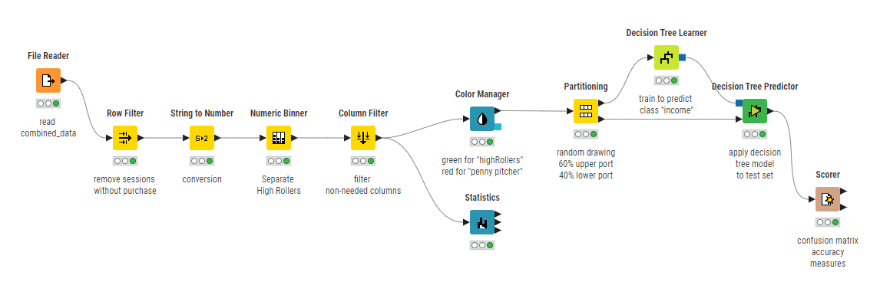

What makes a HighRoller vs PennyPincher?

The OS used by user. Users who are highRoller use IOS, PennyPincher use android, Mac, Windows, Linux

Specific Recommendations to increase Revenue

1. Target promotions to IOS users
2. Target future product develop towards IOS.